Program Data Provider

<Document Title>

Version Number: 1.0
Version Date: October 3, 2025
Draft

Business Intelligence Program Data Provider (PDP)
Strategic Services Compliance Data Division (SSCD)
Compliance Management Directorate (CMD)
Information Technology Branch (ITB)
Canada Revenue Agency

Services du programme d’intelligence d’affaires (SPIA)
Division des services stratégiques et des données d’observation (SSDO)
Direction de la gestion de l'observation (DGO)
Direction générale de l'informatique (DGI)
Agence du revenu du Canada

Document Version History
Table 1: Document Version History
Version # | Version Date | Author | Revision Notes
1.0 | October 3, 2026 | Jason Ryan | Initial draft

Table of Contents
1 Document Version History 1
2 Document Overview 3
2.1 Effective Date 4
2.2 Purpose 4
2.3 Audience 4
2.4 References 4
2.5 Heading 2.5 5
3 Heading 3 5
3.1 Heading 3.1 6
3.1.1 Heading 3.1.1 6
3.1.2 Heading 3.1.2 6
3.1.3 Heading 3.1.3 6
4 Heading 4 6
4.1 Heading 4.1 6
4.1.1 Heading 4.1.1 6
5 Appendix A 6
5.1 Glossary of Terms 7
6 Appendix B 7
6.1 Appendix B Sub-heading 8
7 Document Element Templates 9
7.1 Tables 10
7.2 Figures 10

Document Overview

Effective Date
The <Document Title> came into effect on Month DD, YYYY.

Purpose
<text for Heading 2.2>

Audience
The audience for this document is:
- <group 1>
- <group 2>
- <group 3>

References
Related documents and information:
- <item 1>
- <item 2>
- <item 3>

Heading 2.5
<text for Heading 2.5>

Heading 3
<text for Heading 3>

Heading 3.1
<text for Heading 3.1>

Heading 3.1.1
<text for Heading 3.1.1.>

Heading 3.1.2
<text for Heading 3.1.3>

Heading 3.1.3
<text for Heading 3.1.3>

Heading 3
<text for Heading 3>

Heading 3.1
<text for Heading 3.1>

Heading 3.1.1
<text for Heading 3.1.1.>

Heading 3.1.2
<text for Heading 3.1.3>

Heading 3.1.3
<text for Heading 3.1.3>

Heading 4
<text for Heading 4>

Heading 4.1
<text for Heading 4.1>

Heading 4.1.1
<text for Heading 4.1.1>

Appendix A

Glossary of Terms
This glossary contains definitions of the acronyms and abbreviations used in this document.
Table 2: Glossary
Acronym/Abbreviation | Description
ADW | Agency Data Warehouse
AWS | Amazon Web Services
BI | Business Intelligence
BPM | Business Performance Measurement
CRA | Canada Revenue Agency
eBCI | e-Business Computing Infrastructure
ETL | Extract Transform and Load
ITB | Information Technology Branch
OM&R | Operational Monitoring and Reporting
PDP | Program Data Provider
PSABA | Persistent Staging Area - Business Analytical
PSABO | Persistent Staging Area - Business Operations

Appendix B
<text for Appendix B>

Appendix B Sub-heading
<text for Appendix B Sub-heading>

Document Element Templates
This section can be removed from the document once the draft is completed.
This section contains document elements that can be copied to use elsewhere in the document to maintain consistency.

Tables
Table header row should repeat across pages.
Each table should have an associated caption, including table number and description. Caption should be placed above the table.
Table 3: Description of Table
Column 1 | Column 2 | Column 3 | Column 4 | Column 5
<value> | <value> | <value> | <value> | <value>
<value> | <value> | <value> | <value> | <value>
<value> | <value> | <value> | <value> | <value>
<value> | <value> | <value> | <value> | <value>
<value> | <value> | <value> | <value> | <value>
<value> | <value> | <value> | <value> | <value>
<value> | <value> | <value> | <value> | <value>
<value> | <value> | <value> | <value> | <value>
<value> | <value> | <value> | <value> | <value>
<value> | <value> | <value> | <value> | <value>

Figures
Each figure should have an associated caption, include figure number and description. Caption should be placed below the figure.
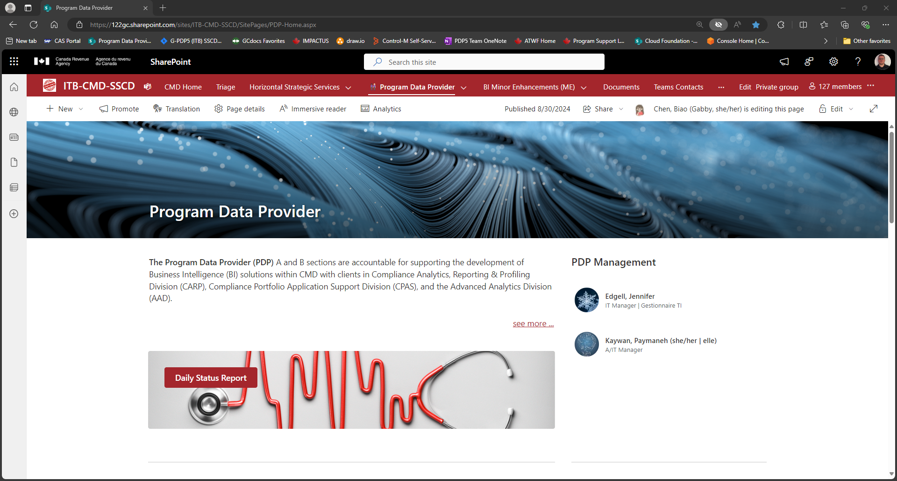
Figure 1: Description of Figure

